Prime Minister’s Hibiscus Award


Lotte Chemical Titan Holding Berhad (“LCT”) has received the Prime Minister’s Hibiscus Award 2025/2026 for Notable Achievement in Environmental Performance, recognizing business leadership in environmental management and promoting greater environmental awareness at the national level.

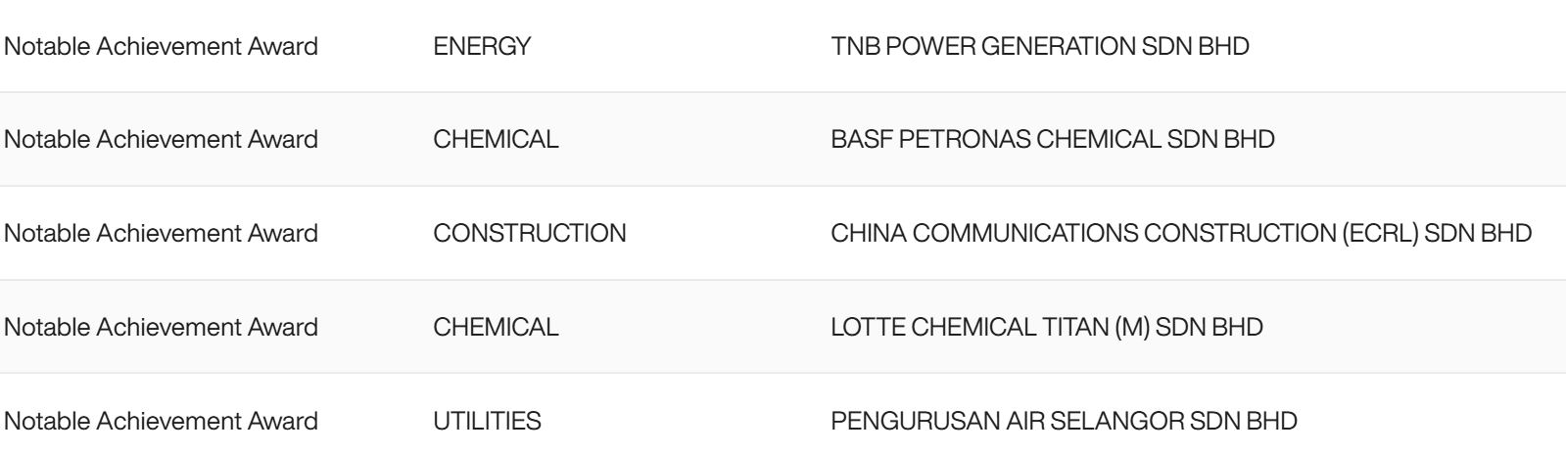

The Prime Minister’s Hibiscus Award, first launched in 1996, is the premier private sector environmental award for business and industry in Malaysia. It was upgraded to the Prime Minister’s Hibiscus Award in 1998 following the approval of former Prime Minister YAB Tun Dr Mahathir Mohamad.
It is one of Malaysia’s longest-standing environmental recognition platforms, and is jointed organized by three of Malaysia's leading private sector non-profit organisations concerned with corporate environmental management and performance, FMM, MICCI, ENSEARCH.
The Award is endorsed by the Ministry of Natural Resources and Environmental Sustainability (NRES) and supported by the Department of Environment (DOE) and the private sector.
The Award assists enterprises in identifying areas for improvement in environmental management for these industries, indirectly facilitating capacity building and partnership development to meet increasingly stringent environmental requirements and global challenges.

